MySQL PHP MVC CRUD Without Framework

# Introduction

This tutorial is for beginners or students. I created a functionality to add, edit and delete a record in PHP with MVC logic without Framework. Also, it explained how to create an MVC pattern in PHP. I hope it will be helpful for you to add a data table in your program.

# Building Our MVC Framework Pattern in PHP

You might be wondering why we would even need to create our own framework when there are already so many good choices out there. The reason for this is so that we can gain an understanding of the underlying principles of MVC.

As we learn more about these principles, we will grow in our understanding of why the excellent MVC frameworks do things the way they do. We are not learning how to create an application in Zend Framework, or in CakePHP. We are learning how MVC works, and by extension, how these frameworks have built upon (or deviated from) the way in which we would expect an MVC framework to be built.

# MVC Model & PHP MVC Project Structure

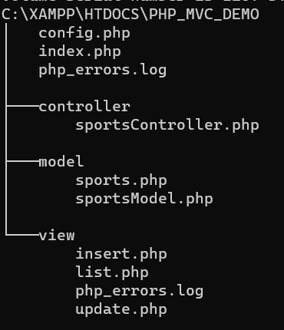

In PhpMyAdmin, create a database named *php_mvc_demo* then create a table named *sports*

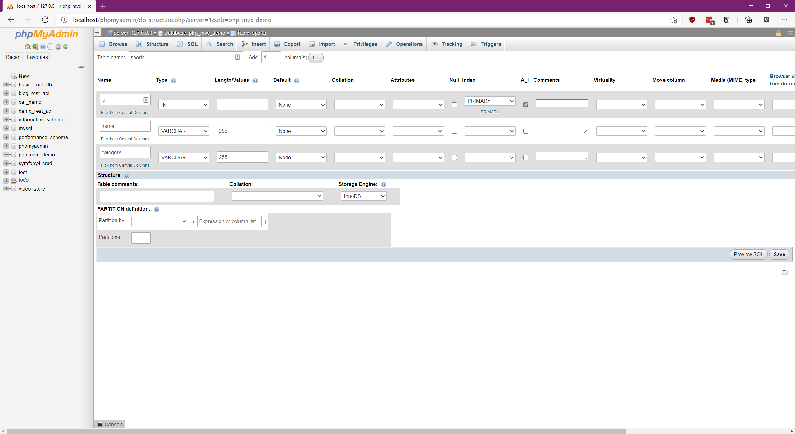

# Section 1

Config.php is used to connect the mysql database to create a connection parameter for mysql host,user,password and database name.

<?php

**class** config

{

**function** **__construct**() {

$this->host = "localhost";

$this->user = "root";

$this->pass = "";

$this->db = "php_mvc_demo";

}

}

?>

A small part of the code in index.php is used to setup a controller object and call mvcHandler() to view the default page list.php.

<?php

**session_unset**();

**require_once** 'controller/sportsController.php';

$controller = **new** sportsController();

$controller->mvcHandler();

?>

In the model folder, create one class for table structure, its named sports and has field and message field to hold messages and data.

<?php

**class** sports

{

// table fields

**public** $id;

**public** $category;

**public** $name;

// message string

**public** $id_msg;

**public** $category_msg;

**public** $name_msg;

// constructor set default value

**function** **__construct**()

{

$id=0;

$category=$name="";

$id_msg=$category_msg=$name_msg="";

}

}

?>

# Section 2

The second section is a sportsModel class structure. We are going to explain and show insertRecord(), updateRecord(),selectRecord() and insertRecord(). The sportsModel class is used to access the function sportsController. The sportsModel class constructor receives a mysql connection parameter to work with the database.

<?php

**class** sportsModel

{

// set database config for mysql

**function** **__construct**($consetup)

{

$this->host = $consetup->host;

$this->user = $consetup->user;

$this->pass = $consetup->pass;

$this->db = $consetup->db;

}

// open mysql data base

**public** **function** open_db()

{

$this->condb=**new** mysqli($this->host,$this->user,$this->pass,$this->db);

**if** ($this->condb->connect_error)

{

**die**("Error in connection: " . $this->condb->connect_error);

}

}

// close database

**public** **function** close_db()

{

$this->condb->close();

}

// insert record

**public** **function** insertRecord($obj)

{

**try**

{

$this->open_db();

$query=$this->condb->prepare("INSERT INTO sports (category,name) VALUES (?, ?)");

$query->bind_param("ss",$obj->category,$obj->name);

$query->execute();

$res= $query->get_result();

$last_id=$this->condb->insert_id;

$query->close();

$this->close_db();

**return** $last_id;

}

**catch** (Exception $e)

{

$this->close_db();

**throw** $e;

}

}

//update record

**public** **function** updateRecord($obj)

{

**try**

{

$this->open_db();

$query=$this->condb->prepare("UPDATE sports SET category=?,name=? WHERE id=?");

$query->bind_param("ssi", $obj->category,$obj->name,$obj->id);

$query->execute();

$res=$query->get_result();

$query->close();

$this->close_db();

**return** **true**;

}

**catch** (Exception $e)

{

$this->close_db();

**throw** $e;

}

}

// delete record

**public** **function** deleteRecord($id)

{

**try**{

$this->open_db();

$query=$this->condb->prepare("DELETE FROM sports WHERE id=?");

$query->bind_param("i",$id);

$query->execute();

$res=$query->get_result();

$query->close();

$this->close_db();

**return** **true**;

}

**catch** (Exception $e)

{

$this->closeDb();

**throw** $e;

}

}

// select record

**public** **function** selectRecord($id)

{

**try**

{

$this->open_db();

**if**($id>0)

{

$query=$this->condb->prepare("SELECT * FROM sports WHERE id=?");

$query->bind_param("i",$id);

}

**else**

{$query=$this->condb->prepare("SELECT * FROM sports"); }

$query->execute();

$res=$query->get_result();

$query->close();

$this->close_db();

**return** $res;

}

**catch**(Exception $e)

{

$this->close_db();

**throw** $e;

}

}

}

?>

# Section 3

Section 3 is the controller code part. The sportsController has mvcHandler() and the CRUD functions insert(), update(),delete() and list(). mvcHandler() receives request and execute. This request shows views according to call request by user.

<?php

**require** 'model/sportsModel.php';

**require** 'model/sports.php';

**require_once** 'config.php';

**session_status**() === **PHP_SESSION_ACTIVE** ? **TRUE** : **session_start**();

**class** sportsController

{

**function** **__construct**()

{

$this->objconfig = **new** config();

$this->objsm = **new** sportsModel($this->objconfig);

}

// mvc handler request

**public** **function** mvcHandler()

{

$act = **isset**($_GET['act']) ? $_GET['act'] : **NULL**;

**switch** ($act)

{

**case** 'add' :

$this->insert();

**break**;

**case** 'update':

$this->update();

**break**;

**case** 'delete' :

$this -> **delete**();

**break**;

**default**:

$this->**list**();

}

}

// page redirection

**public** **function** pageRedirect($url)

{

**header**('Location:'.$url);

}

// check validation

**public** **function** checkValidation($sporttb)

{ $noerror=**true**;

// Validate category

**if**(**empty**($sporttb->category)){

$sporttb->category_msg = "Field is empty.";

$noerror=**false**;

} **elseif**(!**filter_var**($sporttb->category, **FILTER_VALIDATE_REGEXP**, **array**("options"=>**array**("regexp"=>"/^[a-zA-Z\s]+$/")))){

$sporttb->category_msg = "Invalid entry.";

$noerror=**false**;

}**else**{$sporttb->category_msg ="";}

// Validate name

**if**(**empty**($sporttb->name)){

$sporttb->name_msg = "Field is empty.";

$noerror=**false**;

} **elseif**(!**filter_var**($sporttb->name, **FILTER_VALIDATE_REGEXP**, **array**("options"=>**array**("regexp"=>"/^[a-zA-Z\s]+$/")))){

$sporttb->name_msg = "Invalid entry.";

$noerror=**false**;

}**else**{$sporttb->name_msg ="";}

**return** $noerror;

}

// add new record

**public** **function** insert()

{

**try**{

$sporttb=**new** sports();

**if** (**isset**($_POST['addbtn']))

{

// read form value

$sporttb->category = **trim**($_POST['category']);

$sporttb->name = **trim**($_POST['name']);

//call validation

$chk=$this->checkValidation($sporttb);

**if**($chk)

{

//call insert record

$pid = $this -> objsm ->insertRecord($sporttb);

**if**($pid>0){

$this->**list**();

}**else**{

**echo** "Somthing is wrong..., try again.";

}

}**else**

{

$_SESSION['sporttbl0']=**serialize**($sporttb);//add session obj

$this->pageRedirect("view/insert.php");

}

}

}**catch** (Exception $e)

{

$this->close_db();

**throw** $e;

}

}

// update record

**public** **function** update()

{

**try**

{

**if** (**isset**($_POST['updatebtn']))

{

$sporttb=**unserialize**($_SESSION['sporttbl0']);

$sporttb->id = **trim**($_POST['id']);

$sporttb->category = **trim**($_POST['category']);

$sporttb->name = **trim**($_POST['name']);

// check validation

$chk=$this->checkValidation($sporttb);

**if**($chk)

{

$res = $this -> objsm ->updateRecord($sporttb);

**if**($res){

$this->**list**();

}**else**{

**echo** "Somthing is wrong..., try again.";

}

}**else**

{

$_SESSION['sporttbl0']=**serialize**($sporttb);

$this->pageRedirect("view/update.php");

}

}**elseif**(**isset**($_GET["id"]) && !**empty**(**trim**($_GET["id"]))){

$id=$_GET['id'];

$result=$this->objsm->selectRecord($id);

$row=**mysqli_fetch_array**($result);

$sporttb=**new** sports();

$sporttb->id=$row["id"];

$sporttb->name=$row["name"];

$sporttb->category=$row["category"];

$_SESSION['sporttbl0']=**serialize**($sporttb);

$this->pageRedirect('view/update.php');

}**else**{

**echo** "Invalid operation.";

}

}

**catch** (Exception $e)

{

$this->close_db();

**throw** $e;

}

}

// delete record

**public** **function** **delete**()

{

**try**

{

**if** (**isset**($_GET['id']))

{

$id=$_GET['id'];

$res=$this->objsm->deleteRecord($id);

**if**($res){

$this->pageRedirect('index.php');

}**else**{

**echo** "Somthing is wrong..., try again.";

}

}**else**{

**echo** "Invalid operation.";

}

}

**catch** (Exception $e)

{

$this->close_db();

**throw** $e;

}

}

**public** **function** **list**(){

$result=$this->objsm->selectRecord(0);

**include** "view/list.php";

}

}

?>

# Section Four

Section four is the view part, when mvcHandler() receives a request and executes the request, it shows views for user. We have created three views in the view folder, which is insert, update and list, which all have HTML design. These views work with *controller*, and the controller works with *model* to get or set records in a database table.

*insert.php*

<?php

**require** '../model/sports.php';

**session_start**();

$sporttb=**isset**($_SESSION['sporttbl0'])?**unserialize**($_SESSION['sporttbl0']):**new** sports();

?>

<!DOCTYPE html>

<html lang=**"en"**>

<head>

<meta charset=**"UTF-8"**>

<title>**Create Record**</title>

<link rel=**"stylesheet"** href=**"../libs/bootstrap.css"**>

<style type=**"text/css"**>

**.wrapper{**

**width: 500px;**

**margin: 0 auto;**

**}**

</style>

</head>

<body>

<div class=**"wrapper"**>

<div class=**"container-fluid"**>

<div class=**"row"**>

<div class=**"col-md-12"**>

<div class=**"page-header"**>

<h2>**Add Sports**</h2>

</div>

<p>**Please fill this form and submit to add sports record in the database.**</p>

<form action=**"../index.php?act=add"** method=**"post"** >

<div class=**"form-group** <?php **echo** (!**empty**($sporttb->category_msg)) ? 'has-error' : ''; ?>**"**>

<label>**Sport Category**</label>

<input type=**"text"** name=**"category"** class=**"form-control"** value=**"**<?php **echo** $sporttb->category; ?>**"**>

<span class=**"help-block"**><?php **echo** $sporttb->category_msg;?></span>

</div>

<div class=**"form-group** <?php **echo** (!**empty**($sporttb->name_msg)) ? 'has-error' : ''; ?>**"**>

<label>**Sports Name**</label>

<input name=**"name"** class=**"form-control"** value=**"**<?php **echo** $sporttb->name; ?>**"**>

<span class=**"help-block"**><?php **echo** $sporttb->name_msg;?></span>

</div>

<input type=**"submit"** name=**"addbtn"** class=**"btn btn-primary"** value=**"Submit"**>

<a href=**"../index.php"** class=**"btn btn-default"**>**Cancel**</a>

</form>

</div>

</div>

</div>

</div>

</body>

</html>

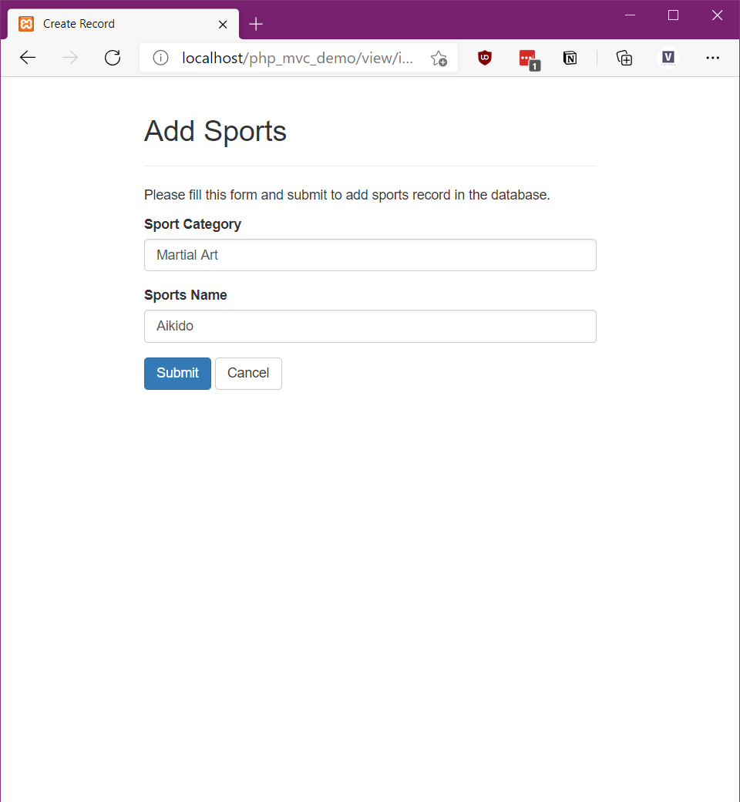

*list.php*

<?php **session_unset**();?>

<!DOCTYPE html>

<html lang=**"en"**>

<head>

<meta charset=**"UTF-8"**>

<title>**Dashboard**</title>

<link href=**"~/../libs/fontawesome/css/font-awesome.css"** rel=**"stylesheet"** />

<link rel=**"stylesheet"** href=**"~/../libs/bootstrap.css"**>

<script src=**"~/../libs/jquery.min.js"**></script>

<script src=**"~/../libs/bootstrap.js"**></script>

<style type=**"text/css"**>

**.wrapper{**

**width: 650px;**

**margin: 0 auto;**

**}**

**.page-header h2{**

**margin-top: 0;**

**}**

**table tr td:last-child a{**

**margin-right: 15px;**

**}**

</style>

<script type=**"text/javascript"**>

$**(**document**).**ready**(*function*(){**

$**(**'[data-toggle="tooltip"]'**).**tooltip**();**

**});**

</script>

</head>

<body>

<div class=**"wrapper"**>

<div class=**"container-fluid"**>

<div class=**"row"**>

<div class=**"col-md-12"**>

<div class=**"page-header clearfix"**>

<a href=**"index.php"** class=**"btn btn-success pull-left"**>**Home**</a>

<h2 class=**"pull-left"**>**Sports Details**</h2>

<a href=**"view/insert.php"** class=**"btn btn-success pull-right"**>**Add New Sports**</a>

</div>

<?php

**if**($result->num_rows > 0){

**echo** "<table class='table table-bordered table-striped'>";

**echo** "<thead>";

**echo** "<tr>";

**echo** "<th>#</th>";

**echo** "<th>Sports Category</th>";

**echo** "<th>Sports Name</th>";

**echo** "<th>Action</th>";

**echo** "</tr>";

**echo** "</thead>";

**echo** "<tbody>";

**while**($row = **mysqli_fetch_array**($result)){

**echo** "<tr>";

**echo** "<td>" . $row['id'] . "</td>";

**echo** "<td>" . $row['category'] . "</td>";

**echo** "<td>" . $row['name'] . "</td>";

**echo** "<td>";

**echo** "<a href='index.php?act=update&id=". $row['id'] ."' title='Update Record' data-toggle='tooltip'><i class='fa fa-edit'></i></a>";

**echo** "<a href='index.php?act=delete&id=". $row['id'] ."' title='Delete Record' data-toggle='tooltip'><i class='fa fa-trash'></i></a>";

**echo** "</td>";

**echo** "</tr>";

}

**echo** "</tbody>";

**echo** "</table>";

// Free result set

**mysqli_free_result**($result);

} **else**{

**echo** "<p class='lead'><em>No records were found.</em></p>";

}

?>

</div>

</div>

</div>

</div>

</body>

</html>

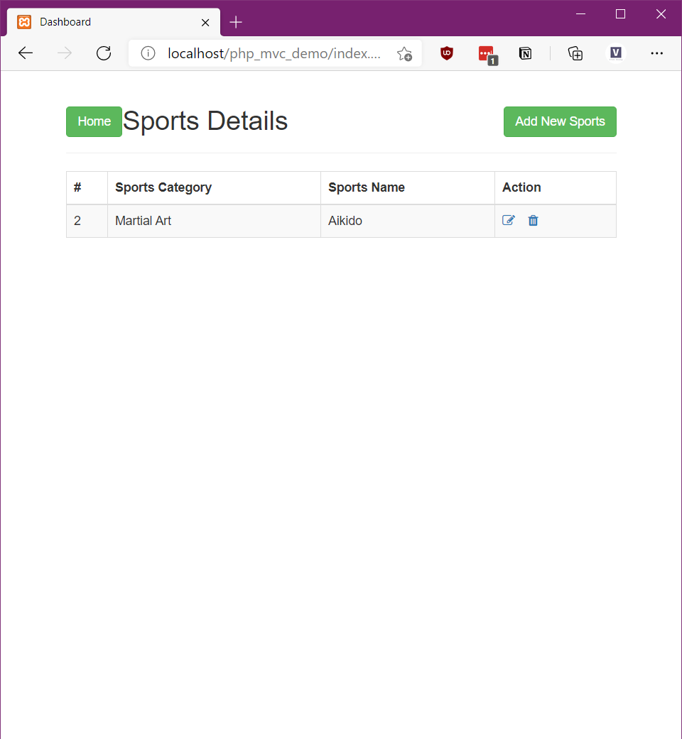

*update.php*

<?php

**require** '../model/sports.php';

**session_start**();

$sporttb=**isset**($_SESSION['sporttbl0'])?**unserialize**($_SESSION['sporttbl0']):**new** sports();

?>

<!DOCTYPE html>

<html lang=**"en"**>

<head>

<meta charset=**"UTF-8"**>

<title>**Create Record**</title>

<link rel=**"stylesheet"** href=**"../libs/bootstrap.css"**>

<style type=**"text/css"**>

**.wrapper{**

**width: 500px;**

**margin: 0 auto;**

**}**

</style>

</head>

<body>

<div class=**"wrapper"**>

<div class=**"container-fluid"**>

<div class=**"row"**>

<div class=**"col-md-12"**>

<div class=**"page-header"**>

<h2>**Update Sports**</h2>

</div>

<p>**Please fill this form and submit to add sports record in the database.**</p>

<form action=**"../index.php?act=update"** method=**"post"** >

<div class=**"form-group** <?php **echo** (!**empty**($sporttb->category_msg)) ? 'has-error' : ''; ?>**"**>

<label>**Sport Category**</label>

<input type=**"text"** name=**"category"** class=**"form-control"** value=**"**<?php **echo** $sporttb->category; ?>**"**>

<span class=**"help-block"**><?php **echo** $sporttb->category_msg;?></span>

</div>

<div class=**"form-group** <?php **echo** (!**empty**($sporttb->name_msg)) ? 'has-error' : ''; ?>**"**>

<label>**Sports Name**</label>

<input type=**"text"** name=**"name"** class=**"form-control"** value=**"**<?php **echo** $sporttb->name; ?> **"**>

<span class=**"help-block"**><?php **echo** $sporttb->name_msg;?></span>

</div>

<input type=**"hidden"** name=**"id"** value=**"**<?php **echo** $sporttb->id; ?>**"**/>

<input type=**"submit"** name=**"updatebtn"** class=**"btn btn-primary"** value=**"Submit"**>

<a href=**"../index.php"** class=**"btn btn-default"**>**Cancel**</a>

</form>

</div>

</div>

</div>

</div>

</body>

</html>

